**PARAN WOMEN**

**GROUP**

**ANNUAL REPORT**

**2024**

**Who PARAN is?**

Paran Women Group is an Indigenous women group collective passionate about long-term solutions and ripple-effect project results. It was formed by indigenous women and registered under registration number S.H. NO. 3745392 as self-help group organization and was legally registered in July 2005. Paran is located in Olollunga, Narok south sub county in Narok County a village that inhabited by a population of approximately 60,000 residents of which its membership of 215 spans among the indigenous women and youth hail from.

**When was it formed**

It was formed in 2005 and consists of 64 women groups with about 3000 members. The groups are self-organized and self-created with the aim of empowering and advancing indigenous women rights.

**Our mission**

Our mission is to uplift women economically, politically and socially through uplifting or their rights and opportunities in Ololunga, Narok County.

Its project intervention programs to reduce poverty strengthen women leadership and environmental governance through socio-economic empowerment initiatives, advocacy, capacity building and training for grassroots indigenous women and youths in general to sustain their socio-economic and livelihood status.

**Our Objectives**

* To promote at grassroots level sustainable development
* To promote different livelihoods options for women with low income
* To promote education among children, women and youth for holistic development.
* To work on various issues like Environment and Climate change, rights and health
* To network with Government, NGOs, and CBOs for advocacy and policy level changes

**Our Values:**

Our values are rooted in our belief of collective work, fairness, inclusiveness, gender equality and respect of traditional knowledge.

**WHAT MAKES US DIFFERENT?** - We are committed to the social, political and economic empowerment of Indigenous women and youth and the self-determine development of our communities. We pride ourselves in collectively addressing our community's' challenges.

**Our Strategies and Interventions**

**Improve decision making power for women and girls in relation to well-being.**Through community awareness and trainings, we seek to empower women and girls so they can stand up for their own rights in terms of all rights

**Improve decision-making power for women and girls in relation to household expenditure and access to resources**through community sensitization. We will measure achievement through a shift in proportion of joint or sole decision-making of women and girls on the use of resources and livelihood, and by measuring an increased number of women and girls in leadership roles

**Improve access to gender-based violence, HIV and reproductive health services and rights**for vulnerable girls and women, including women and girls with a disability. Community sensitization is a key strategy to reduce stigma and discrimination and change health seeking behavior. In the context of women and girls with disabilities, access to information will be a key focus area.

**Paran Activities:**

* Environmental conservation – tree planting, energy saving jikos and briquettes making
* Income generating activities – Bee keeping, poultry keeping, beadwork, kitchen gardening and Traditional medicine
* Women and girls’ rights
* SRHR – Provision of sanitary towels and children mentorship programs (adolescent girls and boys)

**PARAN WOMEN GROUP 2024 ANNUAL REPORT**

Paran Women Group is an Indigenous women group with a mission to uplift women economically, politically and socially in Narok County. It was formed to implement its project intervention Programs to reduce poverty, strengthen women leadership and environmental governance through socio-economic empowerment initiatives, advocacy, capacity building and training for grassroots Indigenous women and youths in general to sustain their socio-economic status.

As Paran women Group we have established tree nurseries in Oloirien, Ololoipangi, Melelo, Mau as well as at Paran women resource Centre. The suitable tree species being promoted according to the area of advocacy entails; Croton, Red cedar, bamboo, Sesbania sesban, Zysgium gumminess Markhamia lutea, Grevillea Robusta, African acacia among others. Seed collection is mainly done through good and well performing mother groups that were trained on appropriate seed harvesting techniques and the desired qualities after attaining certain maturity level. This is strictly followed to minimize seed dormancy as well as harvesting pre-mature and diseased seeds. After collection the seeds are sorted to different tree species, the seeds are dried then planted; there are those that are planted directly, others planted after soaking in water and other seeds are planted without drying or soaking. The seeds are then planted in a tree nursery; after germination it is then transplanted to the planting tubes.

Upon reaching the transplanting stage tree seedlings are then distributed among women groups to go and plant at their respective homes. This is specifically done mark and encourage the women to embrace environmental conservation beginning from grassroots as they extend to the community at large. We train the women on tree nursery establishment.

Some tree seedling is also used to do restoration at Mau Forest where Paran has some specific blocks to plant. Out of the 200 hectares projected we have been able to restore 150hectres with different indigenous tree species.

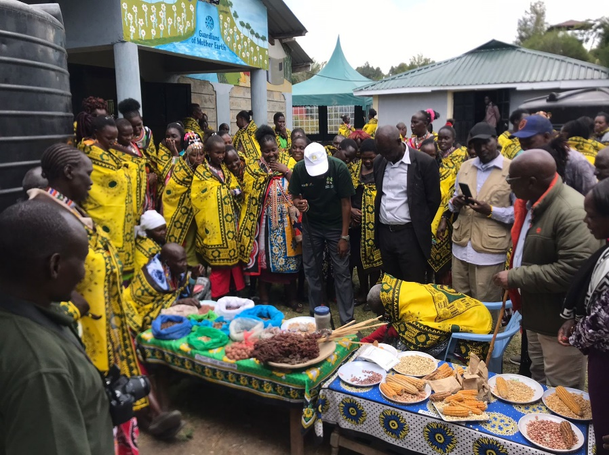

**International Indigenous women’s Day/Exchange program.**

The event was celebrated on 15th October 2024 at the resource center with women groups hailing from Narok south, Narok East and Trans Mara sub counties. Women were able to learn from others, exchanged cultural and diverse ideas from different fields and also learned challenges and appropriate means of addressing them. They were also privileged to learn on some appropriate sustainable techniques such as energy saving jikos and briquette making, toured the Centre demonstration garden to learn on different kitchen gardening methodologies, tree nursery establishment as a means of income generating enterprise if adopted within their respective groups.

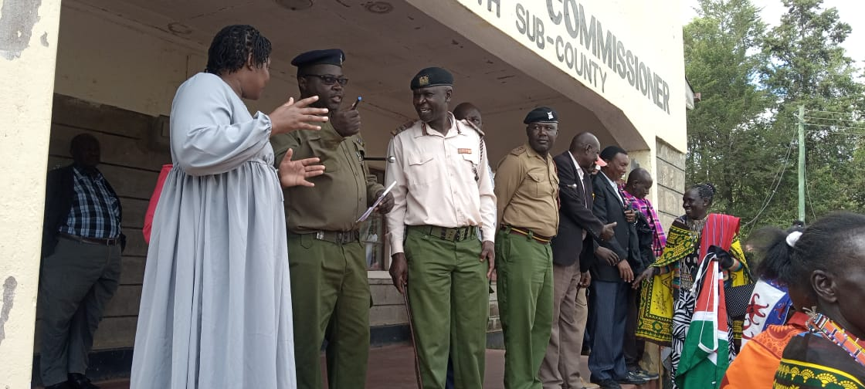

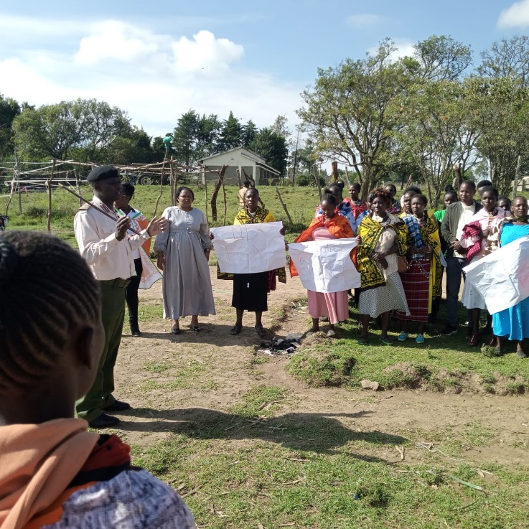**16 Days of Activism to End Gender Based Violence Against Women and Girls-2024.**

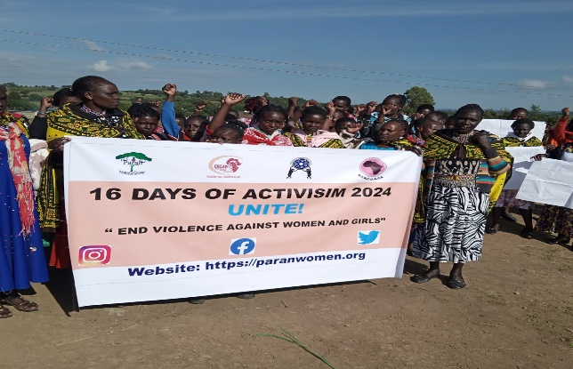This day was celebrated to mark and champion for ending of violence against women and girl child. The occasion started with a walk of members under the leadership of Paran director Mrs. Naiyan Kiplagat from Paran resource Centre to Narok south sub county commissioner’s office at Ololulunga. This was aim to create awareness and sensitize the entire community on the issues that are affecting women and girl child because most of them are not informed on the basic rights thus they are forced to undergo some outdated rites of passage that are health hazards like female genital mutilation, early pregnancies and forced marriages and girl child empowerment through acquisition of education.

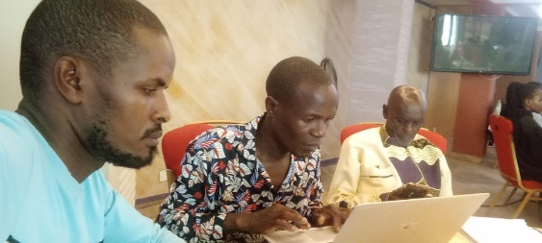

**Staff capacity building program/Workshops**

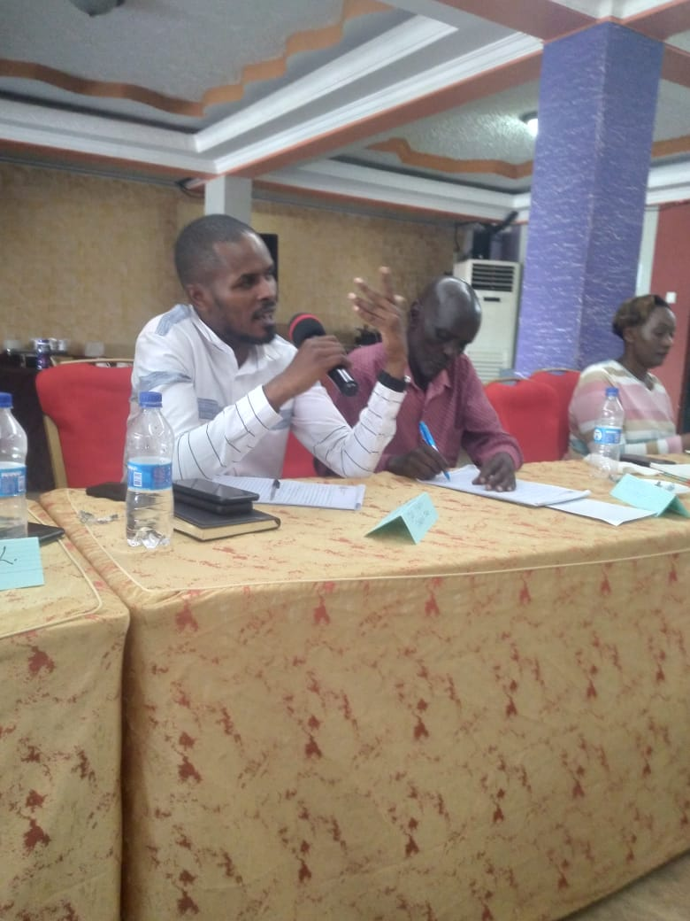**PELUM-Kenya**

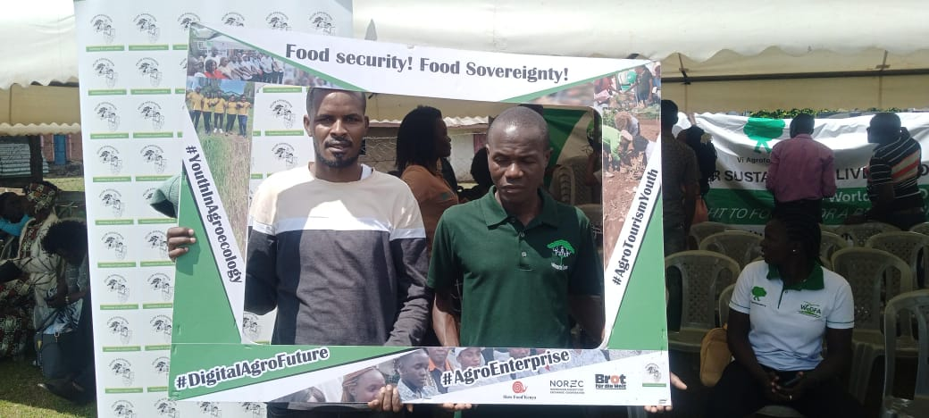Three staff s managed to attend a 5 days’ workshop courtesy of PELUM Kenya network at Busia county in western Kenya with its core partner members. The main objective was to strengthen working capacity among member organizations as well as to have feedback findings and sharing from different core partners on what they managed to achieve from quarter 3 and planning for the last quarter. Some areas of advocacy like Genetically Modified Organisms(GMOs) were shared in detail across the partner members thus becoming a challenge for them to spearhead and look for possible solutions to articulate them.

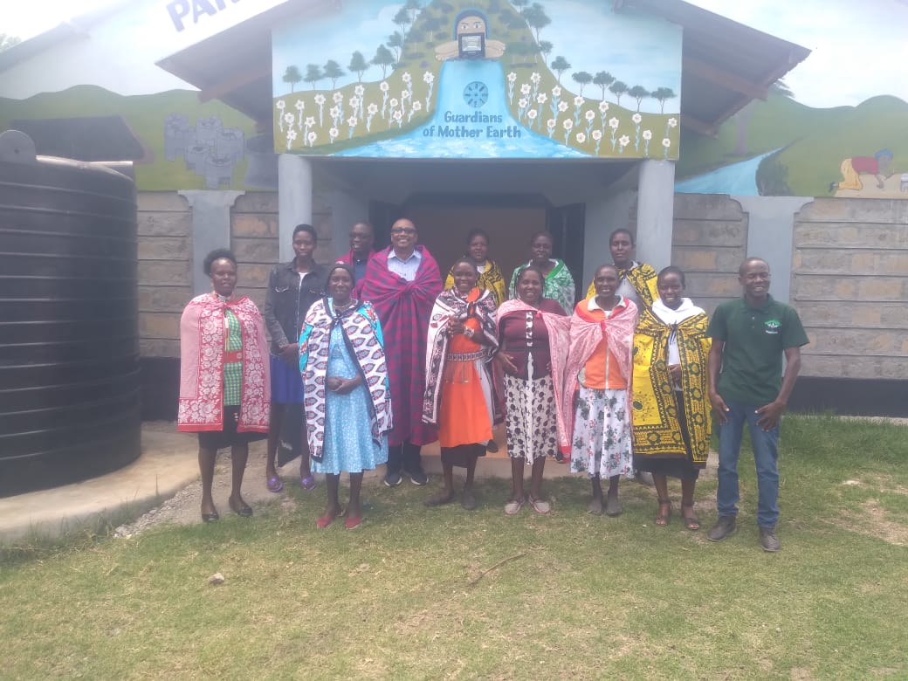

**Farm Africa.**

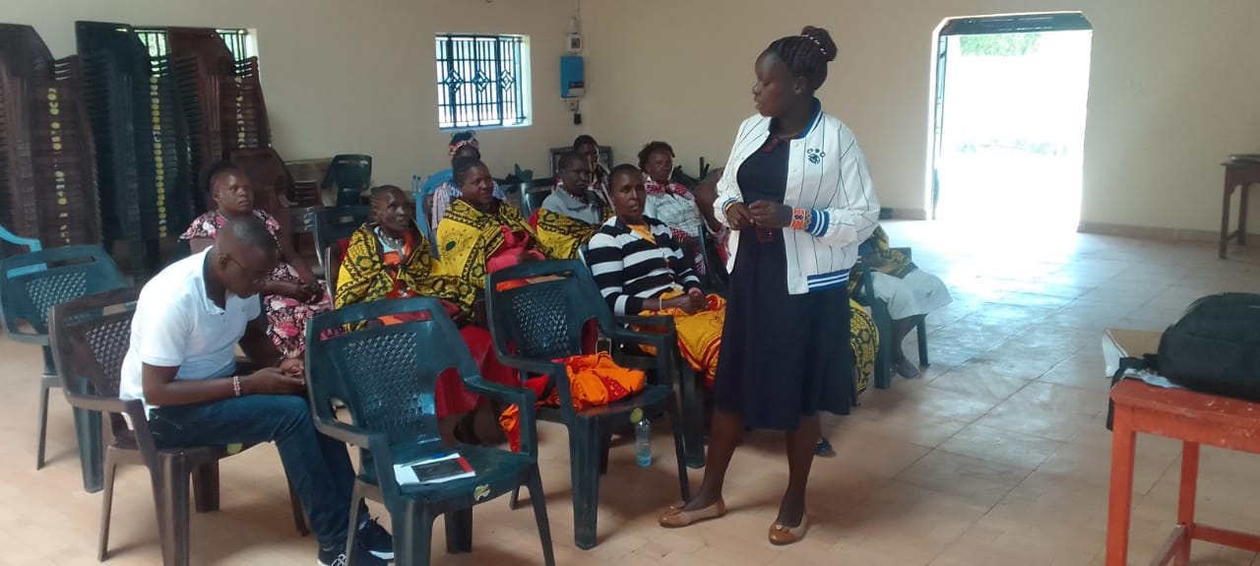Courtesy of Vi Agroforestry, Farm Africa Institute managed to conduct 2 weeks training on Financial management and Leadership skills to both Paran staffs and Board members at large. The training objective was more of awareness creation for each stakeholder to realize the role they have to play and qualities they should adapt to enhance accountability and good governance for the organization stability and progress. A series of practical case studies were precisely sampled out across the workshop that made the participants to clearly highlight and understand the real scenarios, learn from the challenge and improve where there were some gaps.

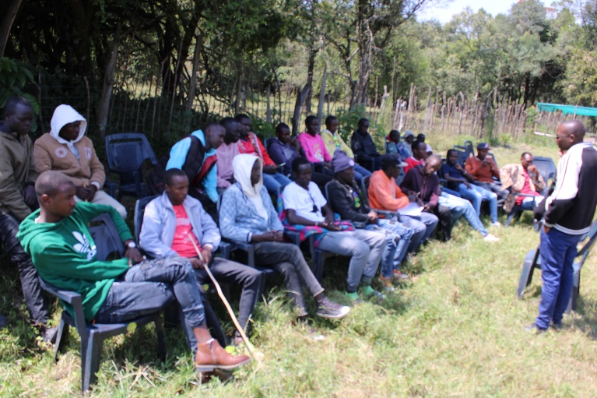

**1.Youth Trainings**

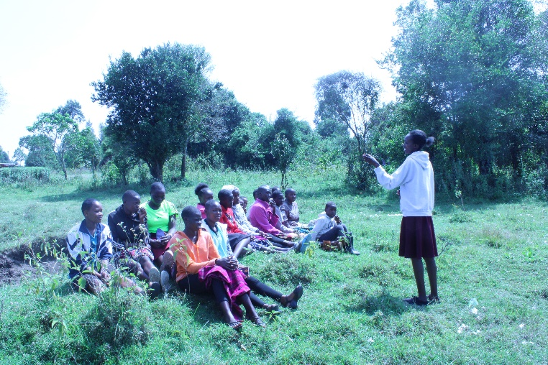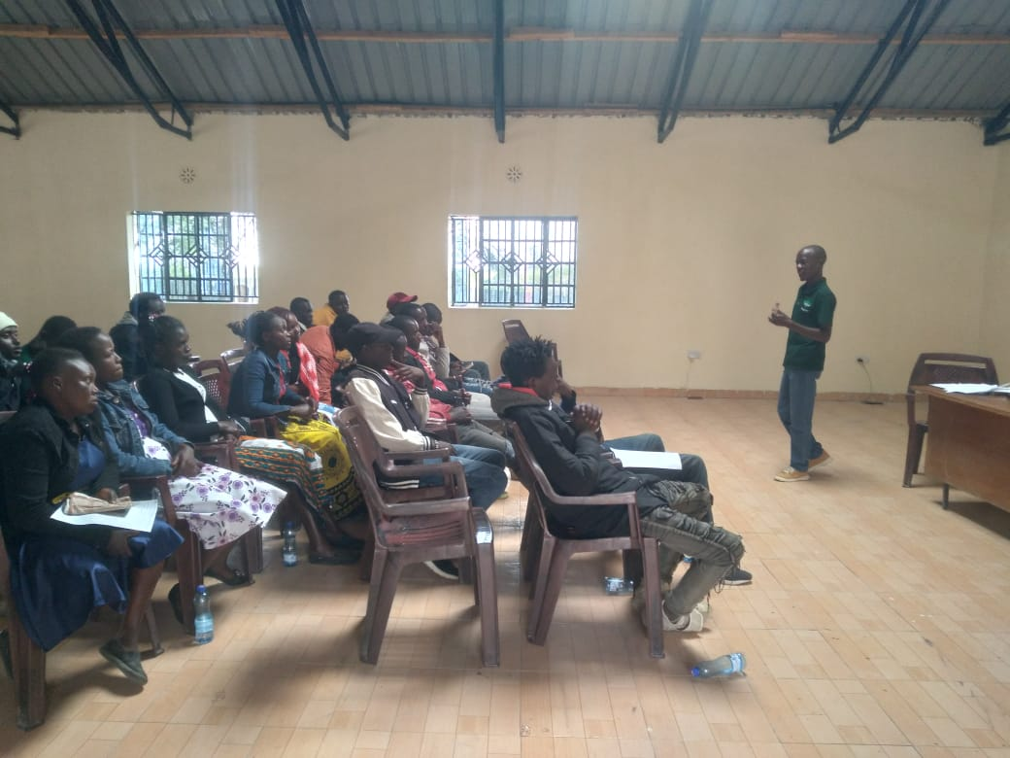During the year we were able to facilitate and conduct trainings across 4 youth groups namely; Olorien Indigenous youths and Eor Uwaso Indigenous youth groups from Narok South sub county and Mosiro youth Alliance and Namayiana Tikako youth group from Narok North Sub county. Across the group’s members precisely outlined the key challenges hindering them to access their legal rights to enable them achieve the sustainable means of livelihoods as well as being limited to meaningfully participate and address the climate justice issues. At some point it was due to limited knowledge they have as part of them are not well informed as far as climate change matters are concerned. Thus it was a great avenue for us as Paran to intervene through different training approaches such as economic empowerment through Village

Savings and Loaning Association(VSLA), Agroforestry and tree nursery establishment as a way of income generation from seedling sells as well as environmental conservation through restoration of degraded lands, Energy saving stoves and briquette making as a holistic way of environment conservation and also minimizes the use of little wood fuel thus limiting excessive cut down of trees at large.

After the training already 2 youth groups i.e. Eor- Uwaso and Olorien Indigenous Youth groups were supported by polytubes, water cans and water storage tanks to start the tree nursery projects at the central point.

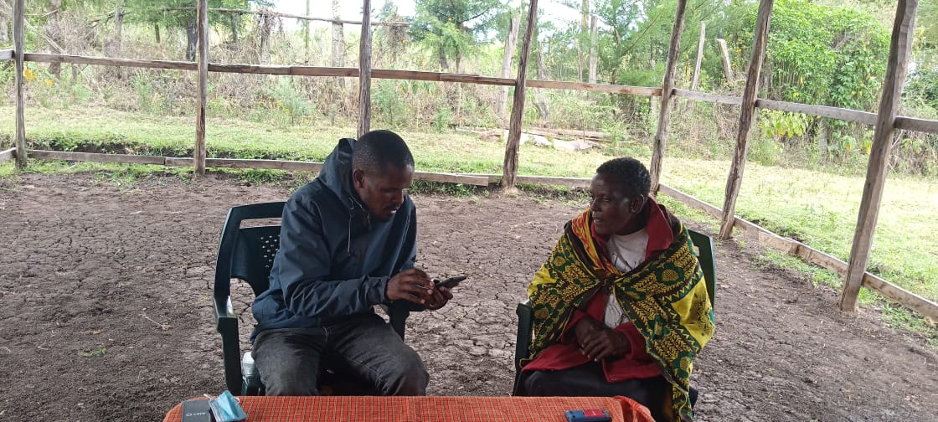

**2.Baseline Survey/Gender Analysis Training.**

This was conducted among Paran beneficiary members across the three main resource canters namely; Melelo, Kotolian and Olorien with the objective of gauging the community perception towards the stipulated program project before rolling them out. The major focus of discussion was centered at both Positive and Negative impacts the project may pose to the community, cultural believes and gender involvement that may either make the activity to stale or prosper.

Across the discussion some positive issues emerged from members of both genders on why each and every individual must have a role to play whenever a particular project is initiated in order to make it succeed. Some case studies were given out basing on previous and the current scenarios as far as women’s roles in the community are concerned. Some male spouses testified that as a now woman have been able to bring up some transformation at their household level through the support they are offering to the family to enhance livelihood improvements thus sharing of roles. This has been realized through Village loaning and associations at the group level, adoption and initiation of kitchen gardens at their households that support them to have a continuous stable vegetable production as well as earn income from the surplus sales; something that initially used to be impossible as they were denied access to land for farming.

On the other hand, youths confirmed that as at now they can also access some rights to own some small livestock’s and even be given some land portions to practice farming and other climate justice activities thus posing a great role in community transformation.

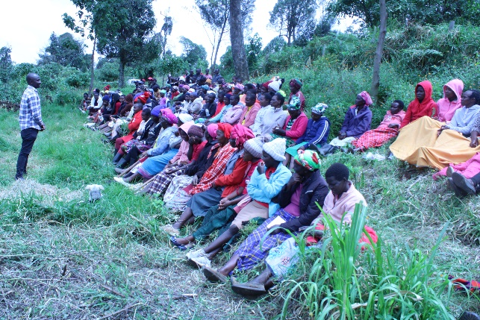

**3.Sustainable Farming/Climate Justice Training-MAU groups**

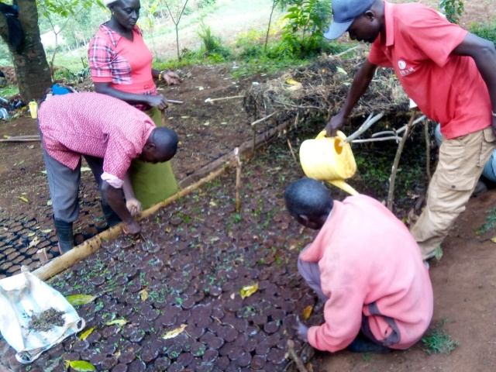We conducted a joint sustainable smart agriculture and climate justice training in September to a total of …farmers from the 7 formed and registered farmer groups at Mau in Narok South namely; Senetwet, Tuiyai, Sagamian women group,

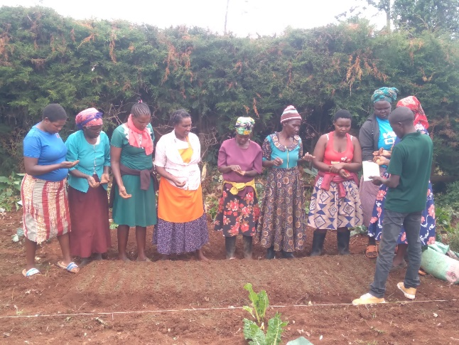Taunet Ne Leel, Kammaueck and Kalyet God willing groups. Farmers were sensitized and trained on the importance of environmental conservation and the need to adopt smart agriculture technologies as a holistic means in relation to climate change matters. After the training the groups were supported by polytubes to establish tree nurseries at their respective groups. Propagation and production of indigenous food crops, indigenous vegetable and seed multiplication was also taught to farmers. This was done to realize food security as well as to safeguard seed sovereignty to optimize biodiversity and continuous production across the season. We supported the groups with a variety of different vegetable starter seeds to be planted at their demonstration kitchen gardens of which they will be able to obtain seeds after harvesting to be planted at their individual household gardens.

Besides the farmer groups we also managed to work with 2 schools around MAU forest i.e. Sagamian and Mogoyuet primary schools through 4kclubs in the establishment of tree nursery and indigenous vegetable production. The essence was to change the mindset of the learners who perceived farming as a punishment at some point but to realize the importance in it as well as to become the community change agents in different areas of advocacy more so the climate change matters.

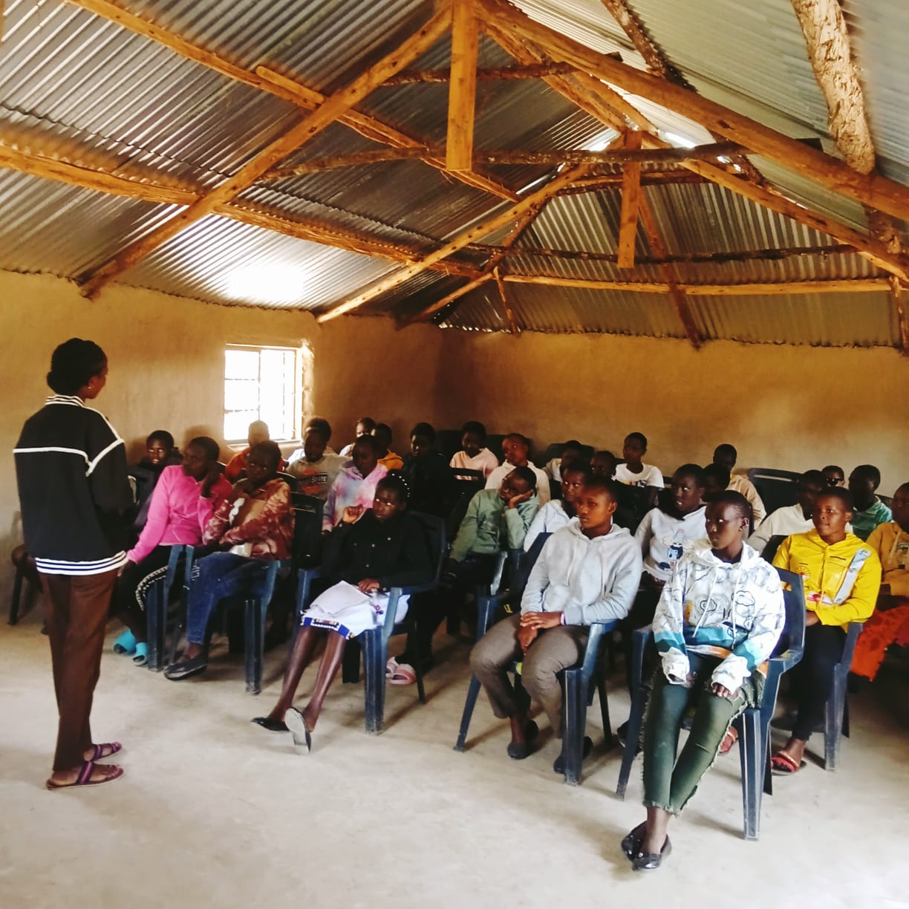

**Viva Girls Program**

This program is supported by MADRE and Indigenous Information Network. The objective of the program is to empower Indigenous girls and to ensure they are reaching their full potential as far as their rights are concerned.

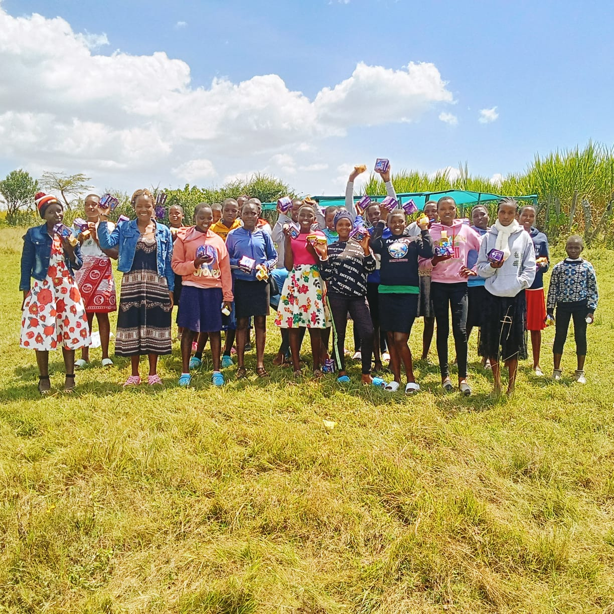Through capacity and strengthening sessions, a total of up to 1600 Girls hailing from Melelo, Eor-Uwaso, Olorien and Olmokonge within Narok South Sub county, Narok East and Transmara West County were empowered adequately on the impacts of FGM, teenage pregnancies, their health rights and linkage to the local health providers thus they are able to visit health facilities while seeking for the required needs. In addition to this a significant number of Indigenous women and girls were also sensitized on issues pertaining leadership affairs, gender equality thus creating an avenue for them to venture into something that was initially belied to be meant for male

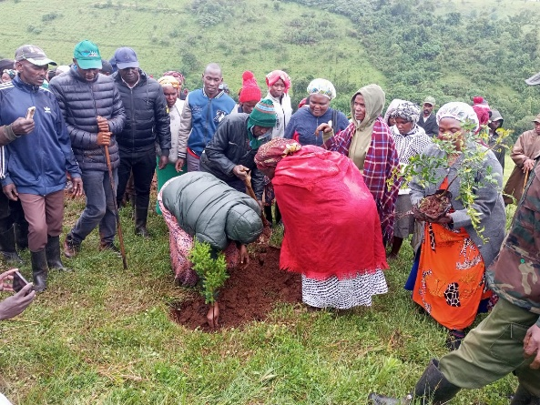

**World Environmental Day**

An inspiring environmental restoration initiative of Mau forest, one of the Kenyas critical water towers is underway, spearheaded by Paran women group. This dedicated collective of indigenous women has committed themselves to the revitalization of their native lands which are crucial not only for their communities but for the ecological health of the entire rift valley region, their efforts are supported by Terramatch, a platform linking reforestation projects with funders, under larger umbrella of the AFR100 initiative. The activities of Paran women are multifaceted, ranking from reforestation to educating the local community about sustainable land use practices. By planting trees, they not only restore the degraded land but also create a buffer that help to protect the intact areas of the forest. These efforts are instrumental in preserving the biodiversity of the region, which includes numerous species of flora and fauna unique to the area.

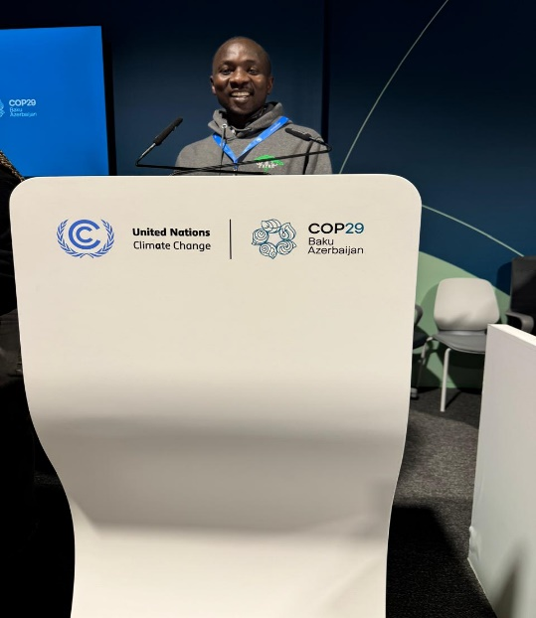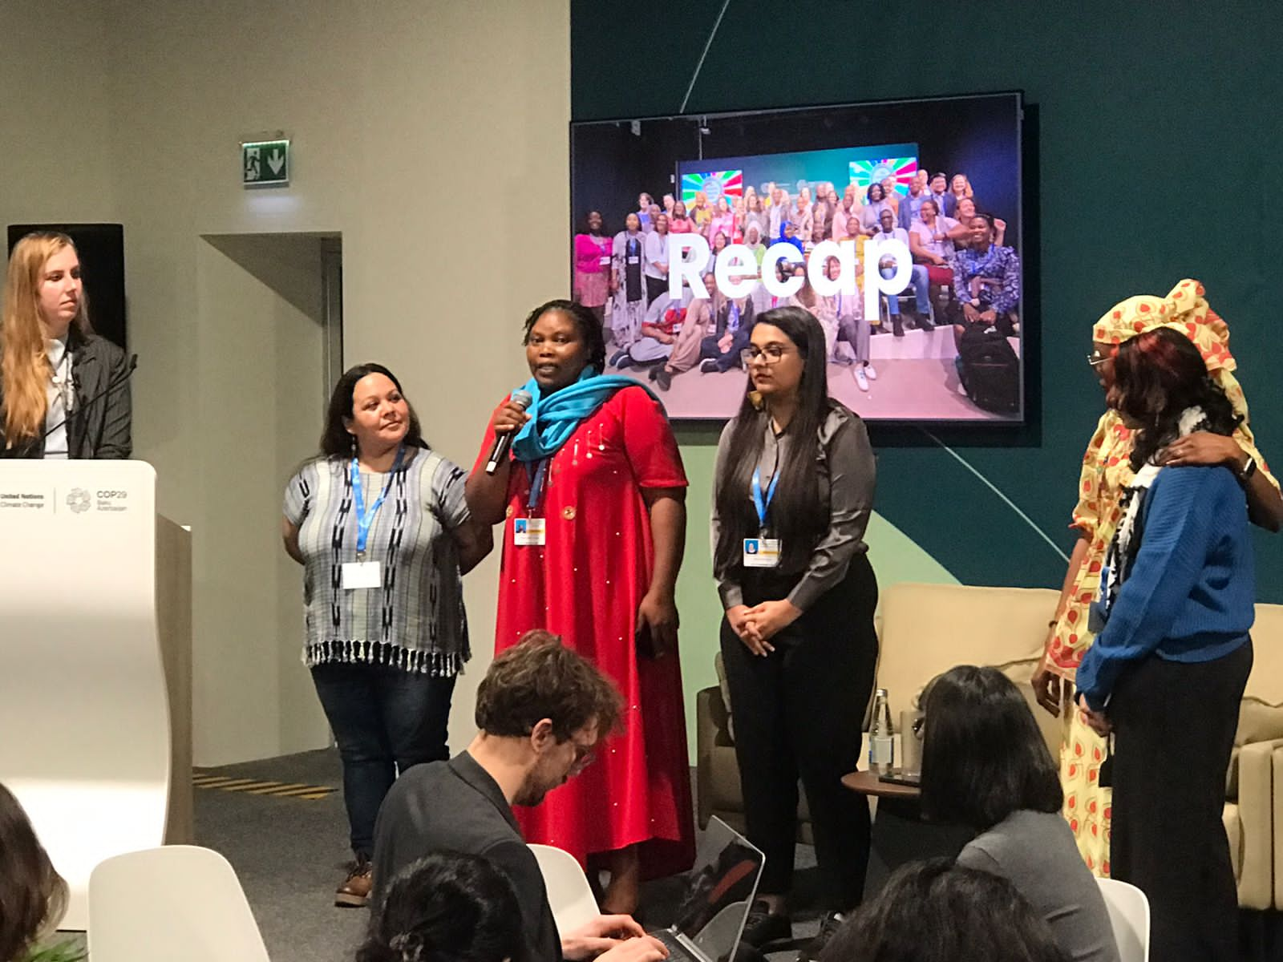

**Conferences/Stakeholders Forum**

**United Nations Forum on Climate Change (COP 29)**

This year’s summit was held at Baku in Azerbaijan where we had privilege as Paran Organization to be represented by Naiyan Kiplagat and Mr. Benard Makinia, with its theme centering on **accelerating progress toward climate goals** through innovative solutions, enhanced financial support and inclusive partnerships.

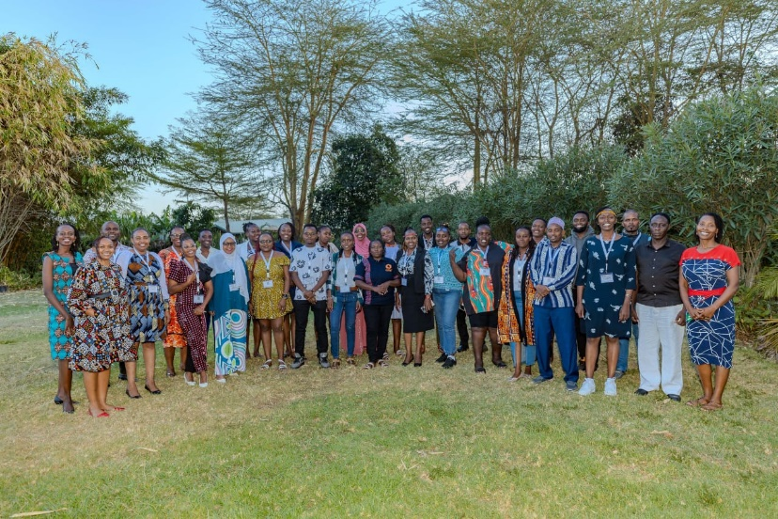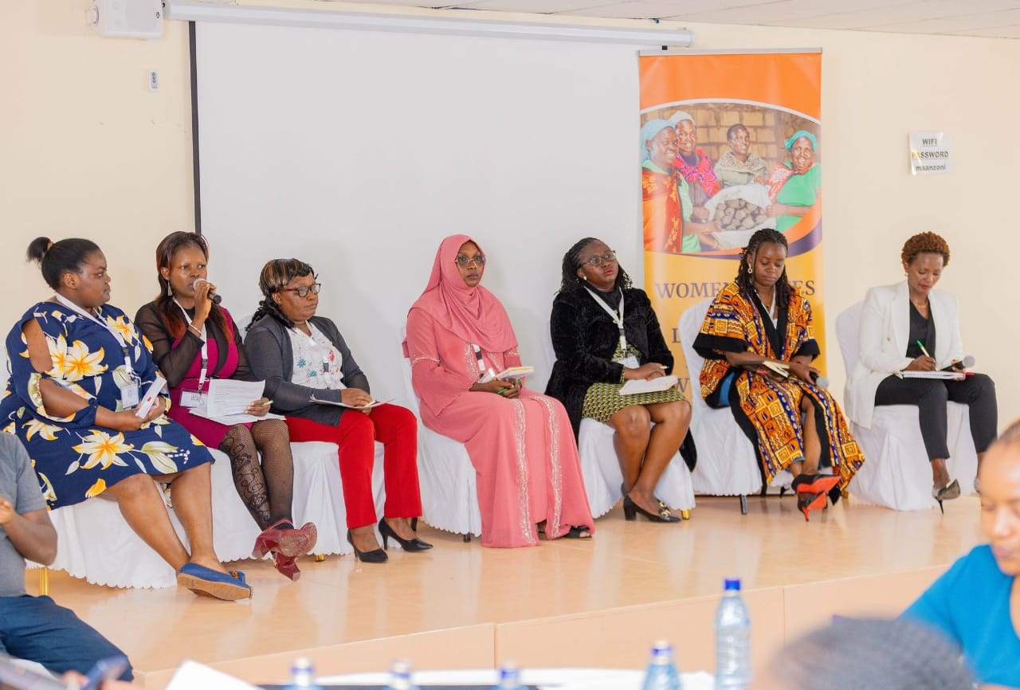

**Women Voice and Leadership (WVL) Women Rights Organizations Festival 2024**

As one of the WVL-Project implementing partner, Paran Women Group joined other 24 implementing partners for the women’s rights Organizations festival, with the themed, “Ignite, Accelerate and Synergies women’s voice and leadership in Kenya”.

Paran women Group Org. Wishes Members and partners’ happy holidays

***Merry Christmas and happy 2025***